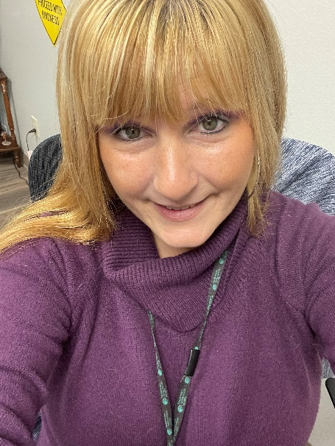My name is Tiffany Walker I was born and raised in Philadelphia. I am alcoholic and an addict. My recovery date is 4/30/2014. I always say my first drink I was 12 years old but really my grandpa when I was three years old use to ask me to grab him a beer out of the fridge and he use to let me open it and take a couple sips. I remember my mom always telling me as a child do not drink it is in my blood on both sides. I didn’t listen, I had my first drug when I was 13 years old. I always use to be that kid who would walk in front door of school and walk out the back to hang out with the party people. I was a wild child. My mom was a single mother and I did get everything I wanted, I didn’t know my mom was poor. My mom worked 72 hours a week and she just wanted me to do well in school. I ran away from my mom for nine days when I was 15 years old. I was going to houses that had parties. The ninth day I came home, as bad as I seen my mom crying I stopped running away. I did drop out of school when I was a junior in high school, my boyfriend at the time now my husband was going to break up with me. I did go back but I was pregnant senior year. I remember being at my Senior Prom dancing, but I really wanted to party. I did not know how to have fun without the drink or drug back then. I had my oldest Natalie, and got married at 21 and a half. I gotten pregnant again on my honeymoon and at the time I was doing diet pills, for years I blamed myself for having a miscarriage, I did not know I was pregnant but still that guilt, and shame! Six weeks later I gotten pregnant with my Kyla, my rainbow baby. You would think I would have been that wife and mother who would stay home especially since I died giving birth to Kyla. My Natalie had to grow up fast and help with Kyla as my husband worked night shift, and I would sleep because I battened and stayed out all hours of the night to party with friends. I would go to my daughter’s school trips hung over, smelling like alcohol but I would just pop a diet pill in and think no one would smell me. I could go on in my act of addiction my today my recovery is my life. I love Recovery, I chase recovery today like I use to chase my parties.

How my Journey started

**April 29, 2014** I was partying with my girlfriends and all the sudden my heart felt like it was coming out of my chest. I went home and told my husband to feel my heart it hurts and going so fast. My husband threw me in the car and got me to the hospital. My heart rate was 195 when they hooked the machines to me. It was pretty scary and I was in there for a week. They were going to have to shock my heart back in place, thank goodness it went back in place. I got-A-fib irregular heartbeat. I take after my dad as it is hereditary. I just brought it on sooner than it was supposed to. I had a lot of thinking to do laying in the hospital. I had to change my life and my family’s. I remember telling the Dr. I was just going to go to sleep and hope the pain in my chest would go away. The Dr. told me if I would have went to sleep I would have never woken up.

**July 26, 2014**  We moved out of Philadelphia to Spartanburg PA- culture shock for me!. I am now three months clean and sobe,r still going through withdrawal, I was having horrible dreams, crazy dreams, shakes, stomach issues. I still was not going to a 12-step meeting. I was what you call a dry drunk. Fourteen months later I finally started going to a 12 step program. I just sat there and listened and they kept telling me I needed a sponsor. I didn’t get a sponsor until three months before my two years. I finally gave in and ask this beautiful women name Deb to sponsor me. Deb was so much fun, never sugar coated anything and always put me in my place. Deb had taught me how to have fun without the drug and drink. I still have my first time doing step work book Jan 6, 2016. I had the best six years with Deb. On January 26, 2020 Deb died; she was always someone I looked up to my mentor always turning my sad face to a smile.

When Deb died I was numb couldn’t think straight. I knew picking up that first drug or drink was not the answer. I started reading the big book again the first 164 pages. I started doing my own step work (to keep my mind clear). I was not ready to get another sponsor I was still grieving. One day I texted a beautiful person, inside and out, like her mom, but she does not like the attention. I ask this beautiful women, inside and out, to be my sponsor. My new sponsor met me for lunch that day and I have been with her for four years now. My sponsor today taught me boundaries, and always do service work to help your recovery. My sponsor today is autonomy and I respect that. My sponsor tells me when I am wrong, or just always there to listen to my cries. My sponsor and I are great friends and help each other out. I am a sponsor myself -which with being a CRS- it is challenging at times, because I have to take the sponsor cap off, and put the CRS cap on. Today I ventured out of my hometown because I am and always will be a social butterfly. I also am involved with a couple committees for recovery, helping to break the stigma with the recovery hub. Helping people is what I always love to do. You have to remember you cannot do recovery for anyone but for yourself. This disease is life or death.

I always say recovery is a roller-coaster ride. One day you are on the top of the roller-coaster ride and one day low on the ride. I always wanted to be a certified recovery specialist and recovery family recovery specialist. I finally working at Stairways behavioral Health Drug & Alcohol Clinic. I started working at Stairways July 17, 2023. Since I have been working at Stairways I already had two bereavements. I do have so much death around me- I have lost my dad that I had finally built a relationship with and then, that fast he died in 2022. My 21 year old nephew Chris died eight months later; his heart gave out. So much death and when Chris’ mom died -my sister- my brain broke. Heather and I did everything together. When Heather hurt I would hurt. I always protected Heather and with her illness I could not she had to do it herself, but Heather had a broken heart losing her son. August 18, 2023 Heather was hospitalized I was going back and forth to Philadelphia and Erie. My job was so understanding. September28, 2023 we had to pull the plug on Heather my heart will probably never be the same, but today I keep going and help others that also helps me, eight months after Heather I have lost my mother-in-law on 5/12/24. I am not telling you about all my death to get sympathy but I am telling you grief, anxiety, depression is real. I have my moments, and it is ok today to get help for yourself. Today I do not even think about picking up. My mental Health I have to work on just like my recovery. Recovery has taught me to just keep getting one day at a time, putting one foot in front of other, and reach out before thinking of picking up the drink or drug. Today I am 44 years old, married to my best friend, my two beautiful daughters are 25 & 21 years old. I have a support team all over and at my work place, I am helping others. I also was the first CRS to go into Erie County prison to work with the women. I love going to the prison to help the women. Also, I will love to go to the PCB conference as a peer. I love going to all the trainings I can get more educated.

Just for today I will get another day.