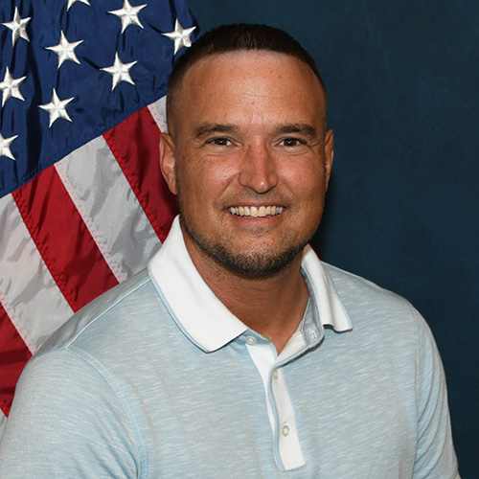
- What motivated you to become a Certified Recovery Specialist?
My peer specialist and mentor at the Liberty House changed my life and not only made it cool to turn your life around but taught me life is better without the chaos and keeping it simple. I was inspired by his lack of judgment on me when I was a mess and his willingness to lend a helping hand for me and so many others. I remember him never giving up on people that others would have. That inspired me.
- What does Recovery mean to you?
Recovery means staying aware of triggers while not letting them dictate my life as best I can, taking time to enjoy the peace of solitude but not isolating, not trying to control every emotion but also not allowing my emotions or thoughts to control me, keeping it simple and doing my best to do the right thing and remember the people that are still down stream but not give everything to them to where my cup is empty. It’s all about balance and moderation I have learned.
- How do you or will you use your personal lived experience to inspire hope and support others?
I can share I know what it’s like to watch life pass by day by day year after year being stuck in my own pain, addiction and depression. I also know how to work through these things by relying on supports and higher power, putting one foot in front of the other, trusting the process and remembering I never want to go back to where I came from. Everyone’s story is different but much of the formula is the same, we have to do something different to get something we never had. I do my best to listen with empathy and no judgment as my mentor did with me.
- What might you say to someone who is struggling in their recovery journey?
You are the author of your story and you have the pen to change the ending. When you can’t control what’s happening to you, control how you respond to it. That’s where your power is. You are not alone in your suffering there are people like me and others who can help but you also have to put the work in and I’ll be here beside you. You are here for a reason lets find out why, together!
- What is something that people might not know about you or something that you would like to share?
I am in the business of helping people but I love animals more than humans! I love my adopted rescue female runt cat named Minnie. We were both homeless and now by the grace of my higher power live in a home.

