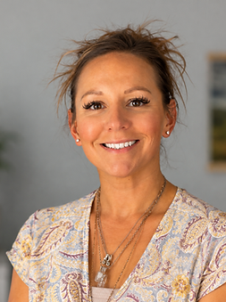
How long have you been in recovery? 4 years.
​How long have you been a Certified Recovery Specialist? 2 years
​What motivated you to become a Certified Recovery Specialist?
What motivated me to become a CRS was my own recovery journey. My last relapse took everything from me. I experienced homelessness, lost custody of my children, became a felon, survived six overdoses, in and out of jail and rehabilitation. Recovery gave me a life I never thought was possible, and I wanted to turn my past into a purpose.
​What does 'Recovery' mean to you?
Recovery is about so much more than not picking up. It’s about healing, growing, and becoming the person I was meant to be. It’s about mending the relationships that were broken, building healthy connections, and learning how to show up for myself and the people I love.
​How do you or will you use your personal lived experience to inspire hope and support others?
I use my personal lived experience by showing others that recovery is possible, no matter how far we’ve fallen. I share my story with honesty and vulnerability to help others feel less alone, and hope my journey gives others the courage to believe that change is possible.
​What might you say to someone who is struggling in their recovery journey?
If someone was struggling in their recovery journey, I would suggest they go to a meeting, ask for help, stay connected. Don’t give up, no matter what.
​What is something that people might not know about you or something that you would like to share?
One thing people might not know about me is that I have an 11-year-old son, and I have not seen him in 6 years because of the choices I made during active addiction. That loss continues to motivate me every day. I share this because I want others to know that even after experiencing painful losses, it is possible to find healing, purpose, and hope in recovery.

